**EE307 HW3**

**Name:吉辰卿 ID:11911303**

**Solution：**

**1-2**：(See the paper below)

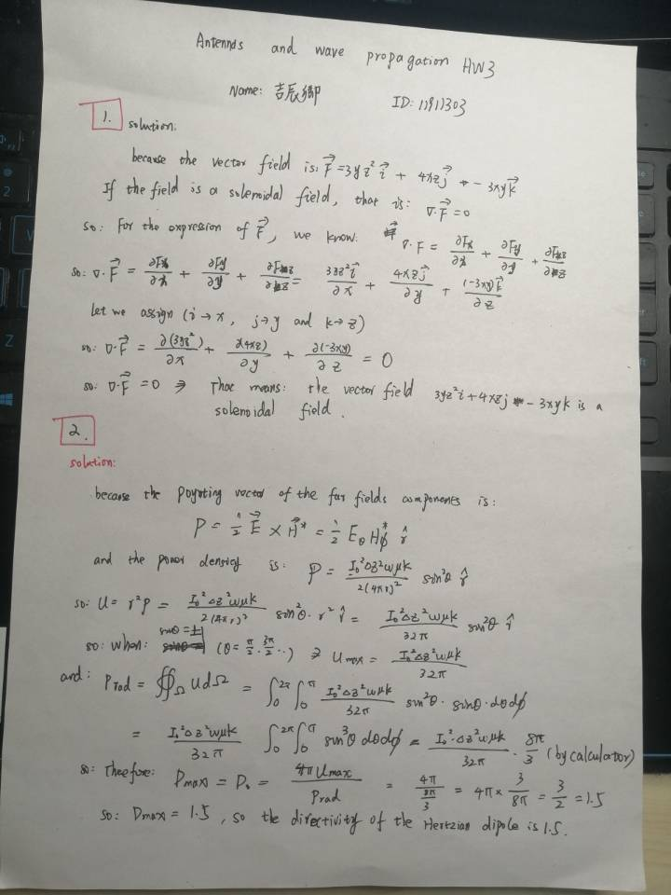

1. **Plot 2D and 3D patterns of Hertzian dipole**

**Result:**

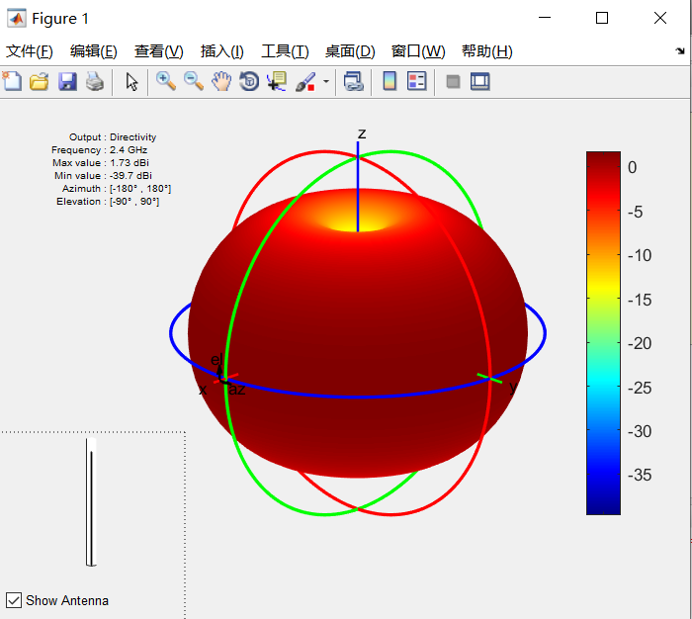 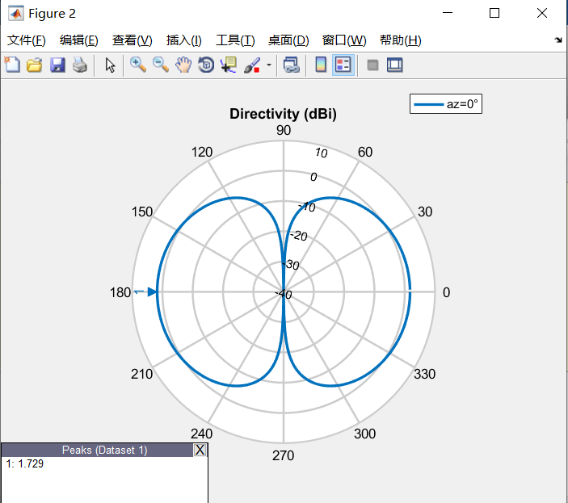

Above Figure: 3D radiation pattern and 2D polar coordinate graph of Hertz Dipole antenna (Images generated by using the antenna Toolbox package in MATLAB 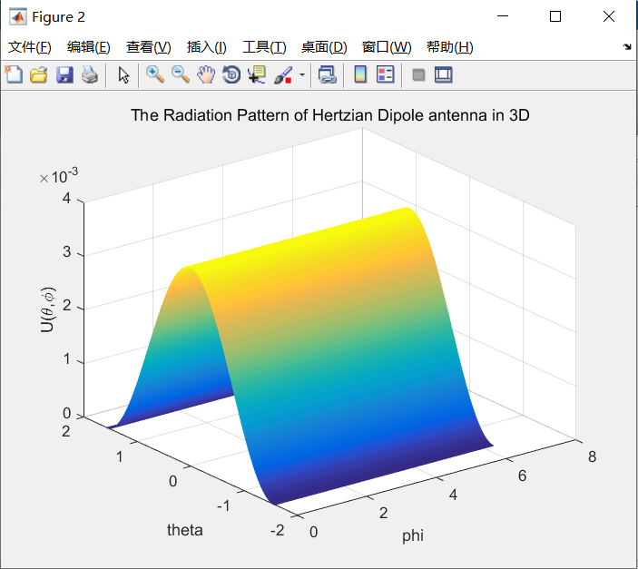 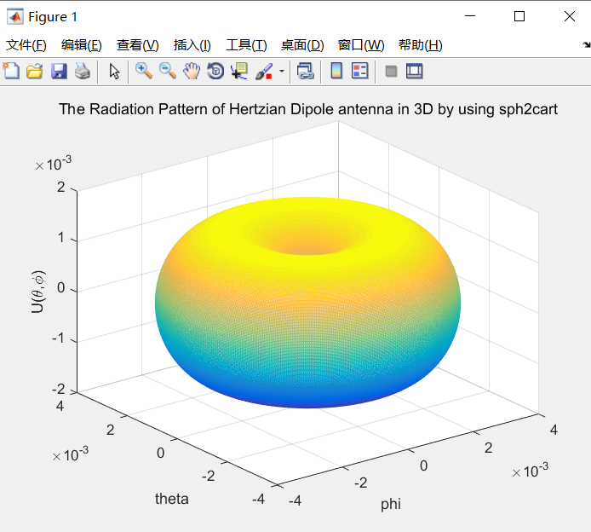

Above Figure: 3D radiation pattern of antenna (simulation result of our own code)

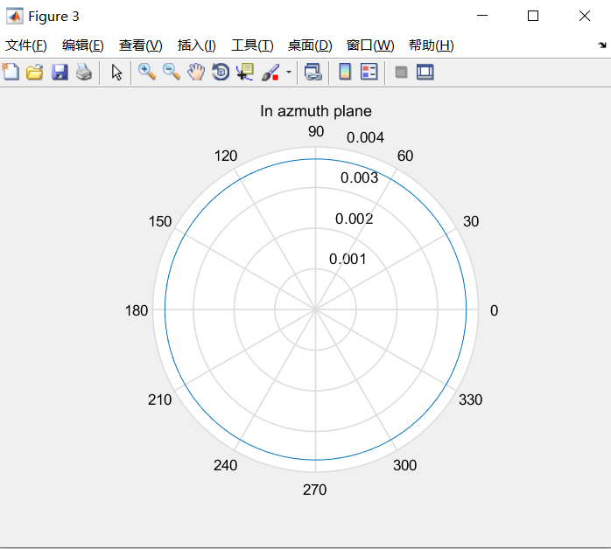 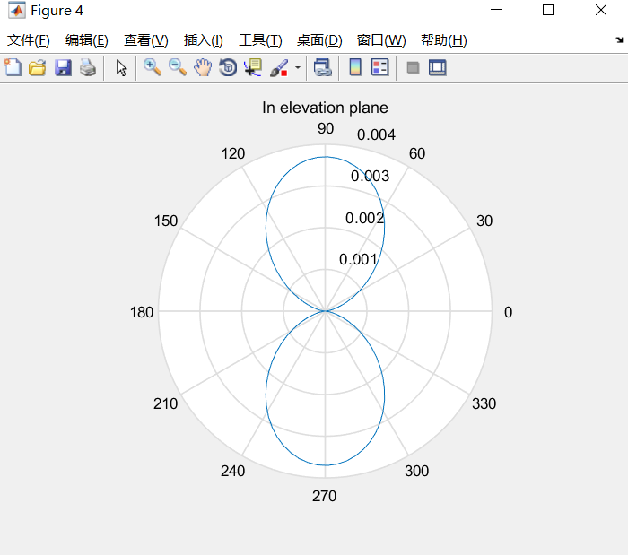

Above Figure: 2D polar coordinates of antenna (The left is the radiation of antenna in Azmuth plane, the right is radiation of antenna in Elevation plane)

**Analysis:**

Before writing the code, we firstly used the toolkit of antenna toolbox in MATLAB to quickly generate the radiation map of Hertz dipole, and the code is as follows:

f=2.4e9;

c=3e8;

len=c/f;

d=dipole('Length',len/200,'Width',len/20000);

figure(1);

pattern(d,2.4e9);

figure(2);

pattern(d,2.4e9,0,1:1:360);

Then, by the formula provided on the course ppt, we can obtain the power density of the Hertz dipole antenna as follows:

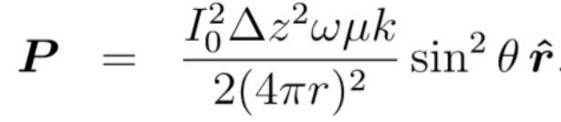

Therefore, using what we learned last time, we can obtain the radiation intensity U of the Hertz dipole by multiplying the above equation by the square of r. So, I can still plot the 3D radiation pattern of this Hertz dipole antenna which based on the intensity of the radiation. However, for the Hertz dipole, we must make some assumptions, as follows:

1. The antenna’s working frequency is 2.4GHz.
2. The total length of the antenna is 1/200 of the operating wavelength. (Because it is an ideal dipole antenna, we need to make sure that the length of the antenna is much smaller than the operating wavelength)
3. The current flowing through the antenna is constant and uniform, and the value of the current is 1A.
4. The surface material of the antenna is copper, and its relative permeability is about 0.999.

As described in the summary, we can write all the MATLAB code of the simulation, as follows:

clear;

clc;

f_antenna = 2*pi*2.4e9;

c = 3e8;

z0 = 1/200 * (c/(f_antenna/2/pi));

I0 = 1;

miu = 0.9999 *4 * pi *1e-7;

phi = linspace(0,2*pi,500);

theta = linspace(0,pi,500);

[tt,pp] = meshgrid(phi,theta);

U = (I0^2) *(z0^2)*(f_antenna^2 *miu)*(1/c)*(1/(32*pi))*((sin(pp).^2));

[x,y,z] = sph2cart(tt,pi/2-pp,U);

figure(1);

mesh(x,y,z);

title('The Radiation Pattern of Hertzian Dipole antenna in 3D by using sph2cart');

xlabel('phi'),ylabel('theta'),zlabel('U(\theta,\phi)');

figure(2);

mesh(phi,pi/2-theta,U);

title('The Radiation Pattern of Hertzian Dipole antenna in 3D');

xlabel('phi'),ylabel('theta'),zlabel('U(\theta,\phi)');

phi = linspace(eps , 2*pi , 100);

theta = linspace(pi/2, pi/2 , 100);

F_azmuth = (I0^2) *(z0^2)*(f_antenna^2 *miu)*(1/c)*(1/(32*pi))*(sin(theta).^2);

figure(3);

polar(phi,F_azmuth);

title('In azmuth plane');

theta = linspace (-pi,pi,100);

F_elevation = (I0^2) *(z0^2)*(f_antenna^2 *miu)*(1/c)*(1/(32*pi))*((sin(theta).^2));

figure(4);

polar(theta,F_elevation);

title('In elevation plane');

Finally, Based on the above analysis and comparison, we found that the simulation results by using the toolkit of MATLAB were basically the same as those by our own code. (The unit of 2D graph tool kits was decibels, while the 2D graph we built was based on the value of radiation intensity, so there were some differences).